**Index**

|  |  |  |  |  |
| --- | --- | --- | --- | --- |
| **No** | **Title of Practical** | **Date** | **Pg No.** | **Signature** |
| 1 | K-means clustering on the IRIS dataset |  | 1 |  |
| 2 | K-means clustering on the Student Grades dataset. |  | 6 |  |
| 3 | Hierarchical clustering |  | 11 |  |
| 4 | Association mining |  | 16 |  |
| 5 | Decision tree on the Bank-Sample dataset |  | 21 |  |
| 6 | Decision tree on the DT data dataset |  | 25 |  |
| 7 | Simple Linear Regression |  | 27 |  |
| 8 | Logistic Regression |  | 30 |  |
| 9 | Hadoop installation on Ubuntu in standalone mode |  | 33 |  |
| 10 | Perform Hadoop installation on Ubuntu in Pseudo Distributed mode |  | 41 |  |

**PRACTICAL NO 1**

**AIM -** Perform K-means clustering on the IRIS dataset. Plot WSS to determine the optimum number of clusters to use

**STEPS**:

**1**- newiris=iris

head(newiris)

pairs(newiris)

newiris$Species = NULL

newiris[1:5,]

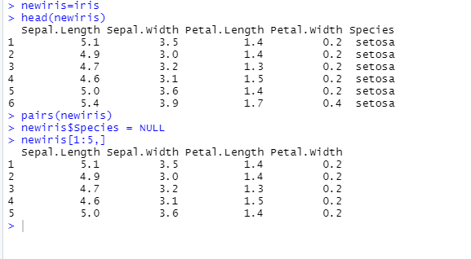

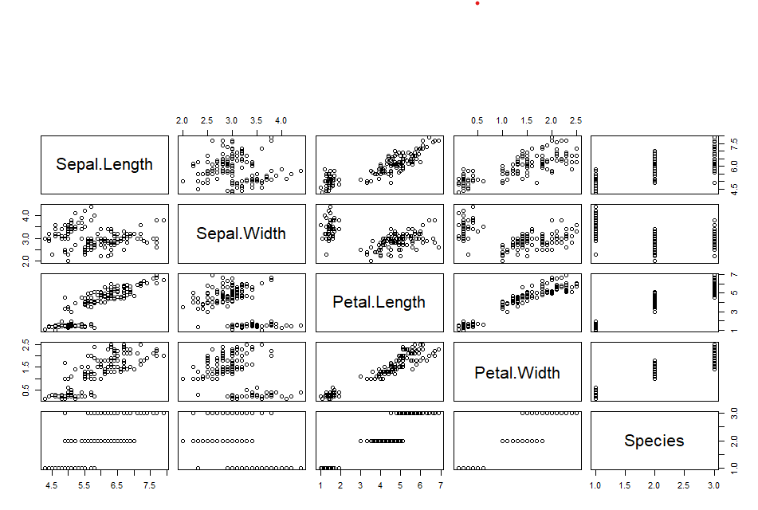

2- # Apply kmeans to newiris, and store the clustering result in kc.

# The cluster number is set to 3.

kc=kmeans(newiris,3,10)

kc

# Check Cluster variables

kc$cluster

table(iris$Species, kc$cluster)

# Plot the clusters and their centres

plot(newiris[c("Sepal.Length", "Sepal.Width")], col=kc$cluster)

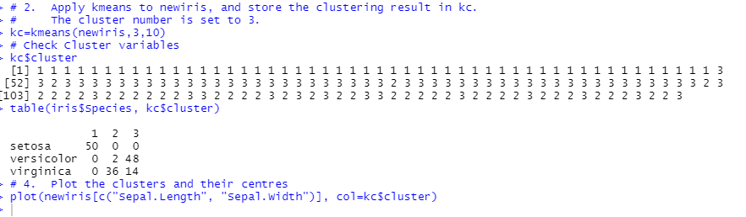

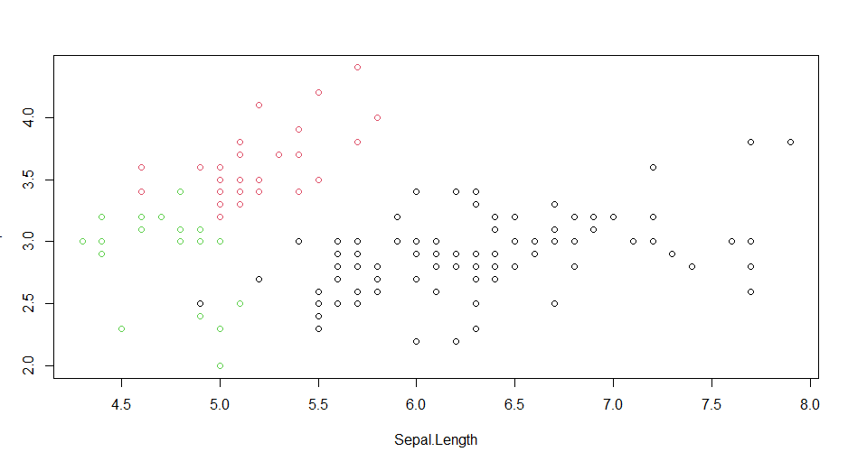

**3-** # Mark Cluster centers

points(kc$centers[,c("Sepal.Length", "Sepal.Width")], col=1:3, pch=8, cex=3)

library('factoextra')

library('tidyverse')

library('ggplot2')

fviz_cluster(kc,data=newiris)

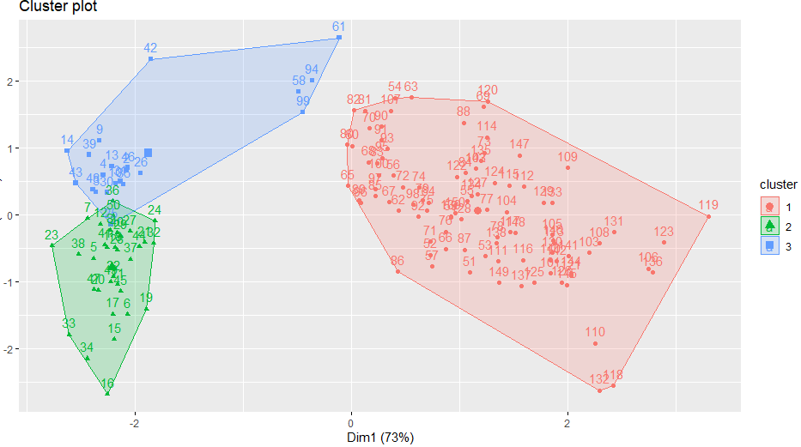

**4-** k2=kmeans(newiris,2,25)

k3=kmeans(newiris,3,25)

k4=kmeans(newiris,4,25)

k5=kmeans(newiris,5,25)

ggplot(aes(Sepal.Length, Sepal.Width, color = factor(cluster))) + geom_text()

fviz_cluster(k2,data=newiris)

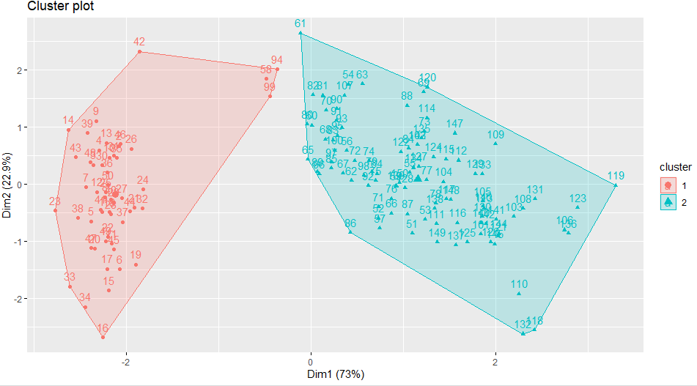

**5-** p1 = fviz_cluster(k2,data=newiris, geom='point') + ggtitle('k=2')

p2 = fviz_cluster(k3,data=newiris, geom='point') + ggtitle('k=3')

p3 = fviz_cluster(k4,data=newiris, geom='point') + ggtitle('k=4')

p4 = fviz_cluster(k5,data=newiris, geom='point') + ggtitle('k=5')

library('gridExtra')

grid.arrange(p1,p2,p3,p4, nrow=2)

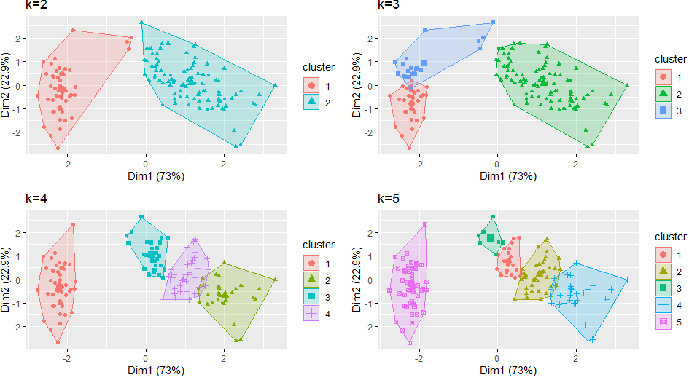

**6-** #optimum number of clusters - wss

set.seed(125)

#compute and plot wss for k=1 to k=15

wss <- numeric(15)

wss

for (k in 1:15)

wss[k]=sum(kmeans(newiris,centers=k, nstart=25 ) $withinss )

wss

# each WSS plotted against the respective number of centroids 1 to 15.

plot(1 : 15, wss, type="b", xlab="Number of Clusters " ,

ylab="Within Sum of Squares" )

# The WSS is greatly reduced when k increases from one to two.

# Another substantial reduction in WSS occurs at k = 3.

# However, the improvement in WSS is fairly linear fork > 3.

# Therefore, the k-means analysis will be conducted for k = 3.

# The process of identifying the appropriate value of k is

# referred to as finding the "elbow" of the WSS curve.



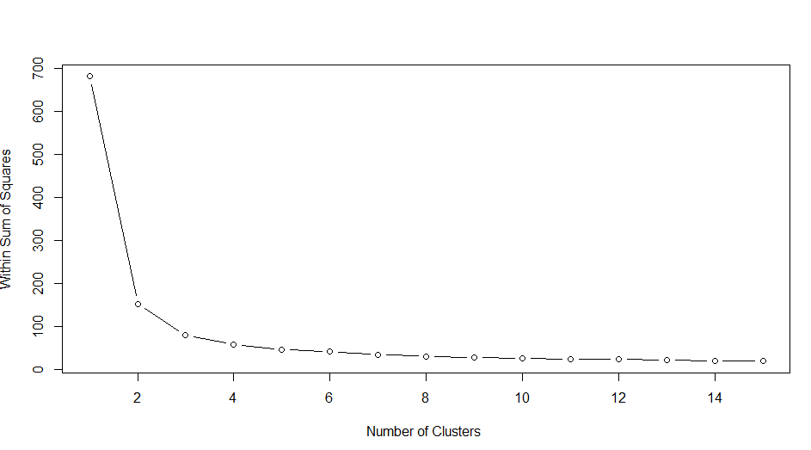

**CONCLUSION**

The practical to perform K-means clustering on the IRIS dataset was successfully executed The WSS plot heled to determine the optimum number of clusters to be three (03)

**PRACTICAL NO 2**

**AIM-** Perform K-means clustering on the Student Grades dataset.

Plot WSS to determine the optimum number of clusters to use

**STEPS**

**1-** # Load libraries from installed pacakges

library (plyr)

library(ggplot2)

library(cluster)

library(lattice)

library(graphics)

library(grid)

library(gridExtra)

#How to set path of an input file in R - set Working Directory

# getwd in r - current working directory

getwd()

# To set working directory use- setwd()

setwd("C:/Users/PRIYANKA/Desktop/Sem 2/BDA Practicals")

grade_input = read.csv('C:/Users/PRIYANKA/Desktop/Sem 2/BDA Practicals/grades_km_input.csv')

str(grade_input)

kmdata = as.matrix(grade_input[,2:4])

str(kmdata)

kmdata[1:5,]

# To find appropriate number of clusters using elbow method- wss

wss = 15

for (k in 1:15)

wss[k]=sum(kmeans(kmdata,centers=k,nstart=25)$withinss)

wss

plot(

1:15,

wss,

type="b",

xlab = "No. of clusters",

ylab = "Withing Sum of Squares")

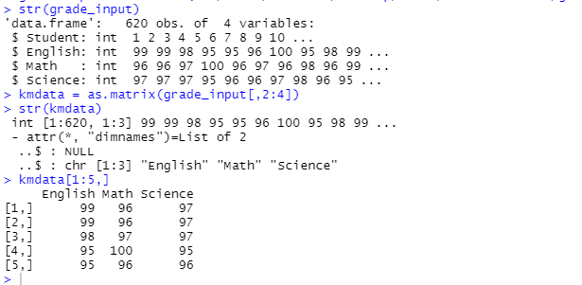

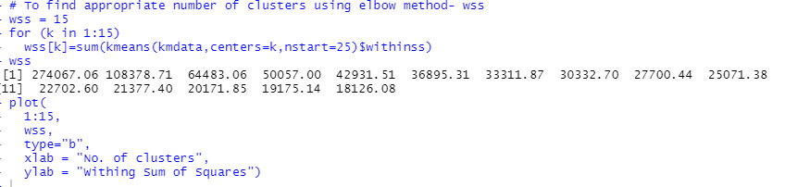

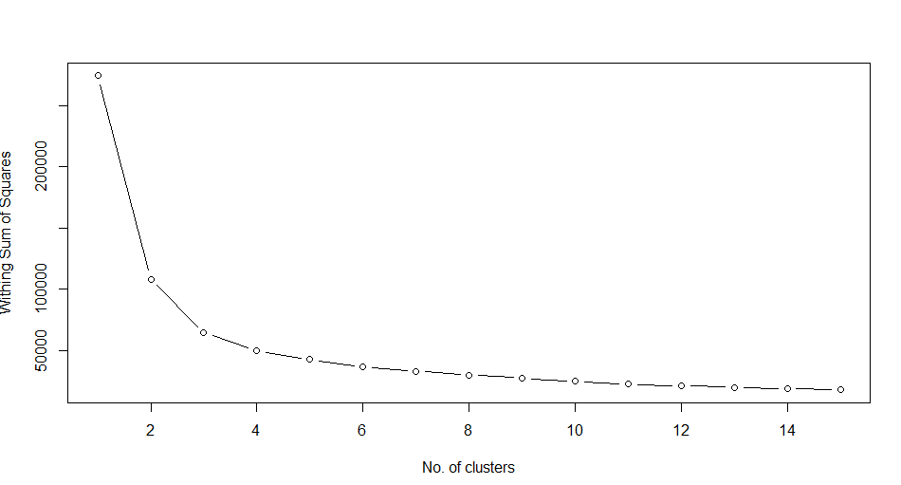

**2-** # Peform KMeans clustering with 3 clusters

km = kmeans(kmdata,3, nstart=25)

km

#visualize the data and assigned clusters

#prepare the student data and clustering results for plotting

df=grade_input[,2:4]

str(df)

km$cluster

df$cluster = factor(km$cluster)

str(df$cluster)

centers = as.data.frame(km$centers)

centers

ggplot(data=df, aes(x=English, y=Math, color=cluster ))+

geom_point() + theme(legend.position="right")

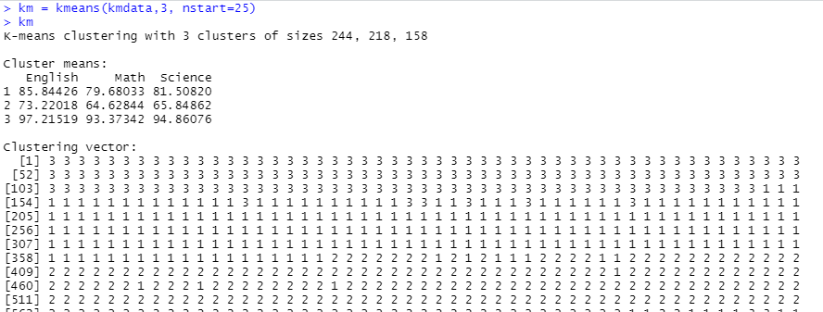

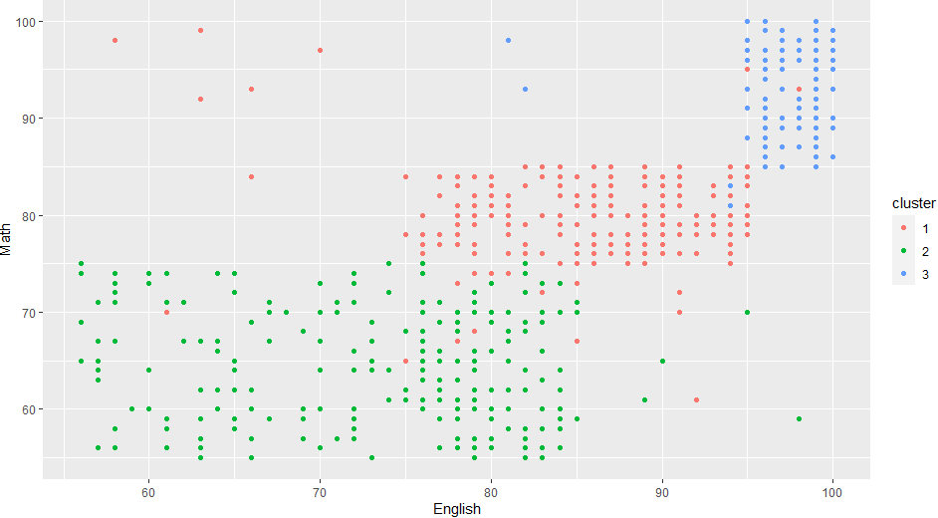

**3-** library('factoextra')

library('tidyverse')

library('ggplot2')

fviz_cluster(km,data=kmdata, geom='point') + ggtitle('k=3')

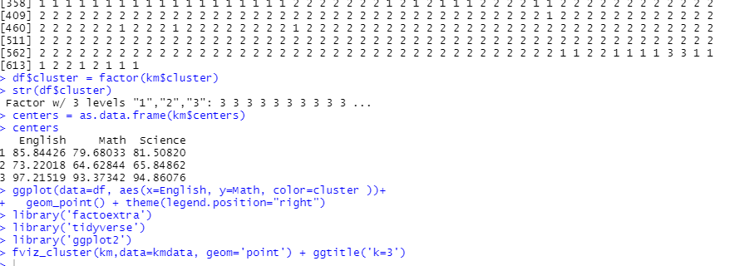

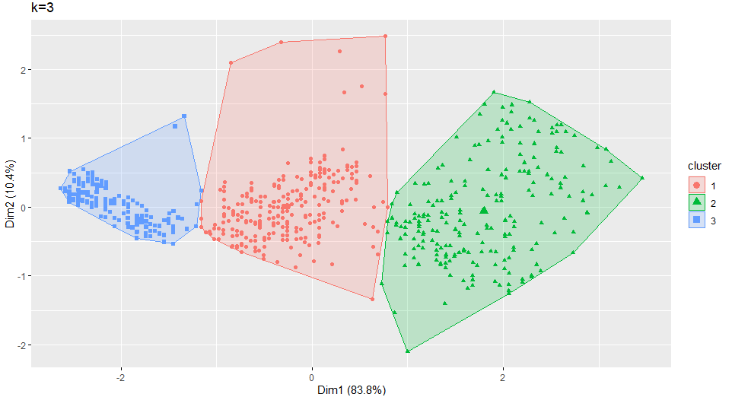

**4-** g1= ggplot(data=df, aes(x=English, y=Math, color=cluster )) +

geom_point() + theme(legend.position="right") +

geom_point(data=centers,

aes(x=English,y=Math, color=as.factor(c(1,2,3))),

size=10, alpha=.3,show.legend = FALSE)

g2 =ggplot(data=df, aes(x=English, y=Science, color=cluster )) +

geom_point () +

geom_point(data=centers,

aes(x=English,y=Science, color=as.factor(c(1,2,3))),

size=10, alpha=.3,show.legend = FALSE)

g3 = ggplot(data=df, aes(x=Math, y=Science, color=cluster )) +

geom_point () +

geom_point(data=centers,

aes(x=Math,y=Science, color=as.factor(c(1,2,3))),

size=10, alpha=0.3,show.legend = FALSE)

tmp = ggplot_gtable(ggplot_build(g1))

library('gridExtra')

grid.arrange(g1,g2,g3, nrow=3)

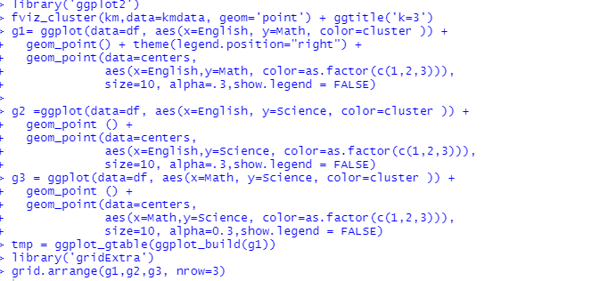

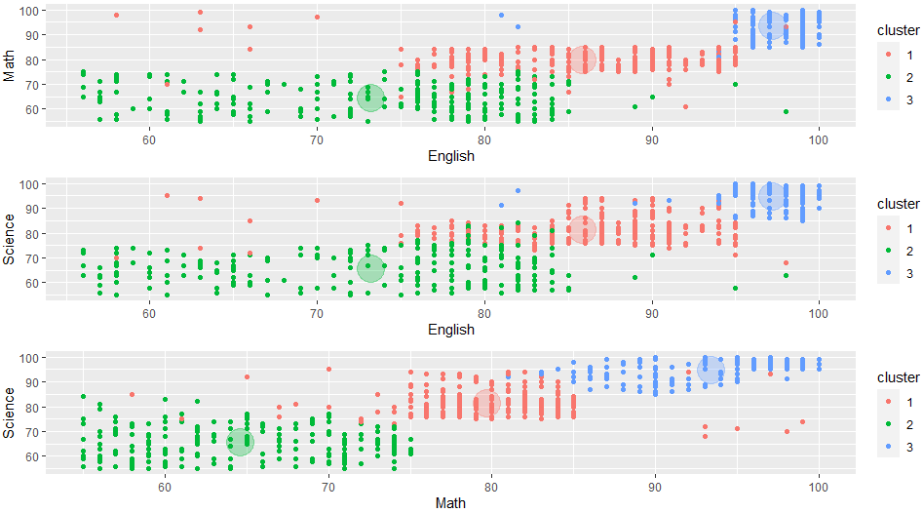

**CONCLUSION**

The practical to Perform K-means clustering on the Student Grades dataset was successfully executed. The WSS plot heled to determine the optimum number of clusters to be three (03)

**PRACTICAL NO 3**

**AIM -** Perform Hierarchical clustering on the Utilities dataset.

Plot its dendogram & Silhoutte Plot

**STEPS:**

**1-** #Clustering in the utlities dataset

utilities = read.csv("C:/Users/PRIYANKA/Desktop/Sem 2/BDA Practicals/utilities.csv")

str(utilities)

utilities

# all possible plots

pairs(utilities[,2:8])

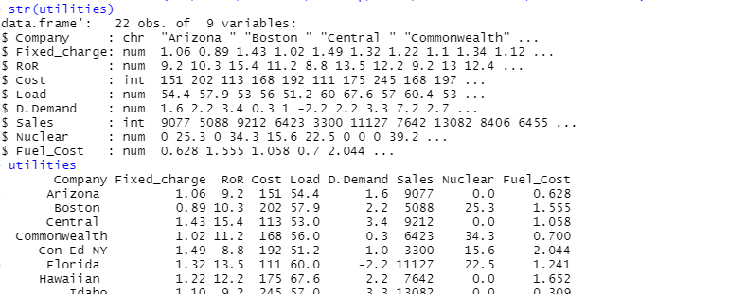

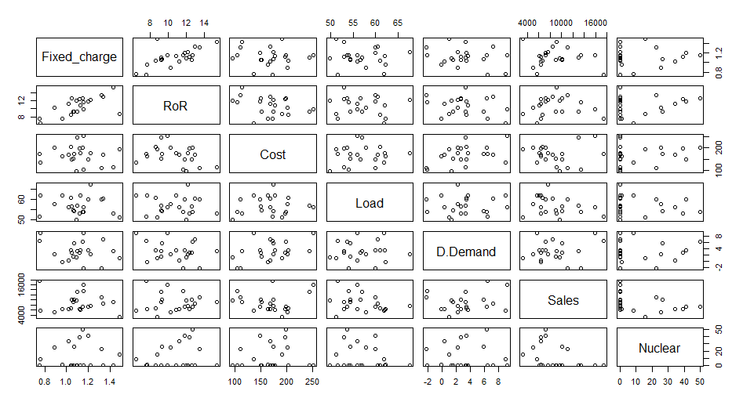

**2-** # scatterplot of Fuel_cost vs Sales

plot(Fuel_Cost ~ Sales,utilities)

with(utilities,text(Fuel_Cost ~ Sales,labels=Company, pos=1,cex=0.7))

utilities

# Normalization - Avg = 0 & std = 1

z=utilities[,2:9]

z

# Calculate mean and Standard dev for entire data set columnwise

m=apply(z,2,mean)

s=apply(z,2,sd)

m

s

z=scale(z,m,s)

#calculating euclidean distance

distance = dist(z)

print(distance,digits=3)

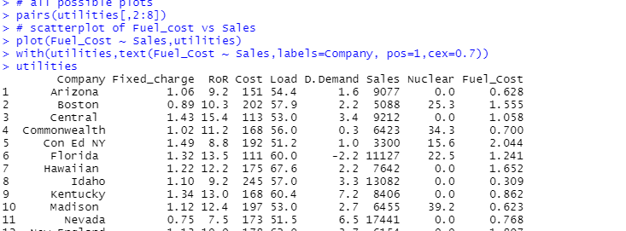

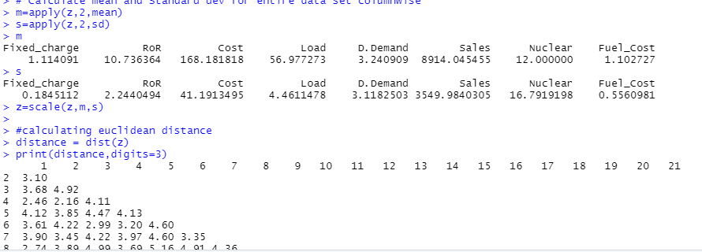

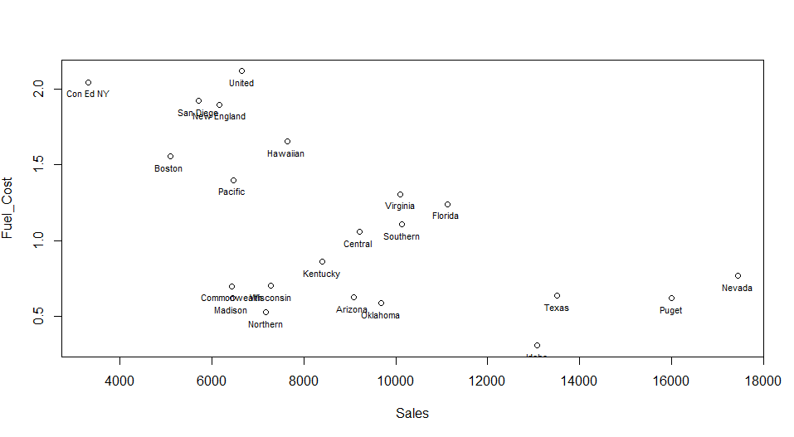

**3-** # Hierarchical agglomerative clustering

# Cluster dendogram with complete linkage

hc.c=hclust(distance)

plot(hc.c)

plot(hc.c,labels = utilities$Company)

plot(hc.c,hang=-1)

# Cluster dendogram with average linkage

hc.a=hclust(distance, method = "average")

plot(hc.a)

plot(hc.a,labels = utilities$Company)

plot(hc.a,hang=-1)

# cluster membership

member.c=cutree(hc.c,3)

member.c

member.a=cutree(hc.a,3)

member.a

table(member.c, member.a)

# cluster means

aggregate(z, list(member.c), mean)

aggregate(utilities[,-c(1,1)], list(member.c), mean)

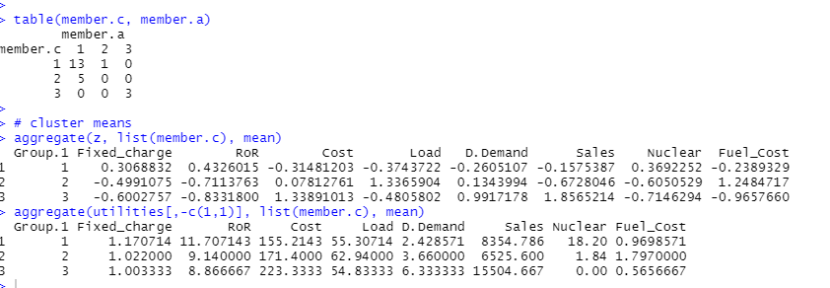

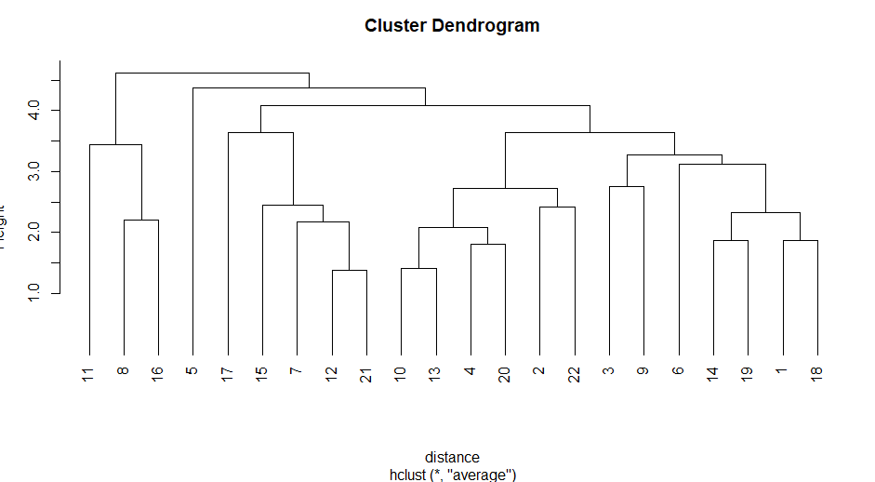

**4-** # Silhoutte Plot

library(cluster)

plot(silhouette(cutree(hc.c,3),distance))

#Scree Plot

wss <- numeric(20)

for (k in 1:20)

wss[k]=sum(kmeans(z,centers=k, nstart=25 ) $withinss )

wss

plot(1 : 20, wss, type="b", xlab="Number of Clusters " ,

ylab="Within Sum of Squares" )

kc = kmeans(z,3)

kc

member.a

member.c

kc$cluster

plot(Sales ~ D.Demand, utilities)

plot(Sales ~ D.Demand, utilities, col =kc$cluster)

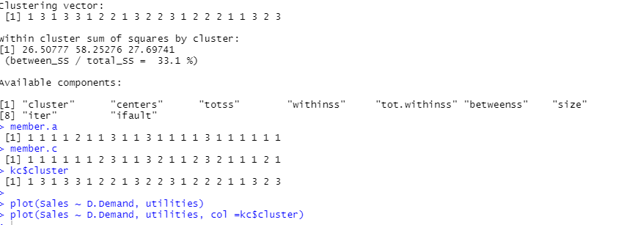

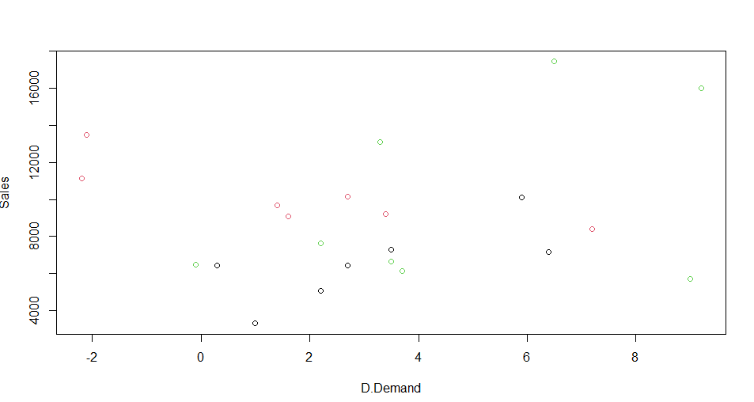

**CONCLUSION**

The Practical to Perform Hierarchical clustering on the Utilities dataset and Plot of dendogram & Silhoutte Plot was successfully executed.

**PRACTICAL NO 4**

**AIM-** Perform Association mining on the Groceries dataset.

Generate frequent itemset of size 1, 2, 3 & 4.

Generate & Plot rules with support=0.001, confidence=0.6

**STEPS:  
1-** library ( 'arules' )

library( 'arulesViz' )

data("Groceries")

View(Groceries)

summary(Groceries)

class(Groceries)

Groceries@itemInfo[1:20,]

Groceries@itemsetInfo[1:20,]

g=Groceries@itemsetInfo[1:20,]

apply(Groceries@data[,1:30],2,

function(r) paste(Groceries@itemInfo[r,"labels"], collapse = ", "))

# Generating frequent itemset of size 1

itemsets = apriori(Groceries)

itemsets = apriori(Groceries, parameter =

list(minlen=1,

maxlen=1,

support=0.02,

target="frequent itemsets"))

inspect(itemsets)

summary(itemsets)

# The top 10 most frequent 1-itemsets

inspect(head(sort(itemsets, by = "support"),10))

# Generating frequent itemset of size 2

itemsets = apriori(Groceries, parameter =

list(minlen=2,

maxlen=2,

support=0.02,

target="frequent itemsets"))

inspect(itemsets)

summary(itemsets)

# The top 10 most frequent 2-itemsets

inspect(head(sort(itemsets, by = "support"),10))

# Generating frequent itemset of size 3

itemsets = apriori(Groceries, parameter =

list(minlen=3,

maxlen=3,

support=0.02,

target="frequent itemsets"))

inspect(itemsets)

summary(itemsets)

# The top 10 most frequent 3-itemsets

inspect(head(sort(itemsets, by = "support"),10))

# Generating frequent itemset of size 4

itemsets = apriori(Groceries, parameter =

list(minlen=4,

maxlen=4,

support=0.02,

target="frequent itemsets"))

inspect(itemsets)

summary(itemsets)

#Rule Generation

rules = apriori(Groceries,

parameter=list(support=0.001,

confidence=0.6,

target="rules"))

inspect(rules)

summary(rules)

inspect(head(sort(rules, by = "support"),10))

# Rule Visualization

plot(rules)

plot(rules@quality)

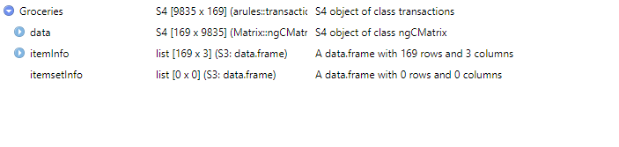

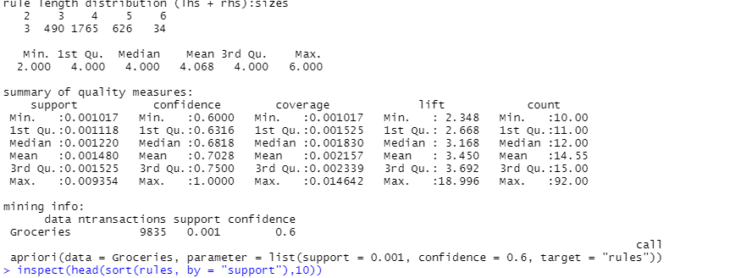

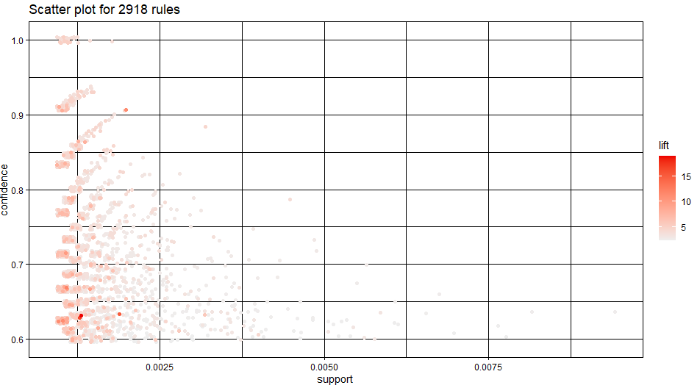

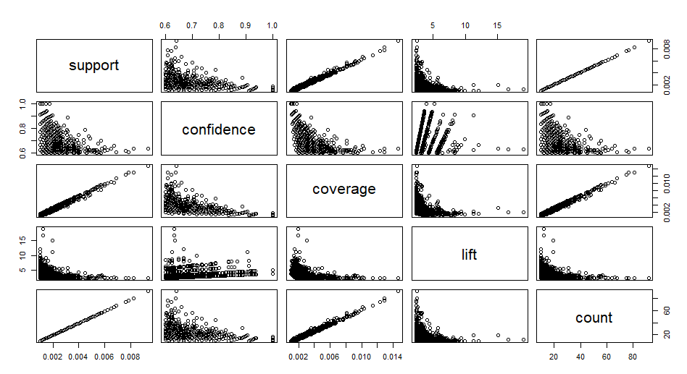

**2-** inspect(head(sort(rules, by = "lift"),10))

confidentRules = rules[quality(rules)$confidence>0.9]

confidentRules

###

plot(confidentRules,

method="matrix",

measure = c("lift", "confidence"),

control=list(reorder=TRUE)

)

highLiftRules = head(sort (rules, by= "lift " ) , 5)

highLiftRules = head(sort(rules, by = "lift"))

highLiftRules

plot(highLiftRules, method = "graph", control = list(type="items"))

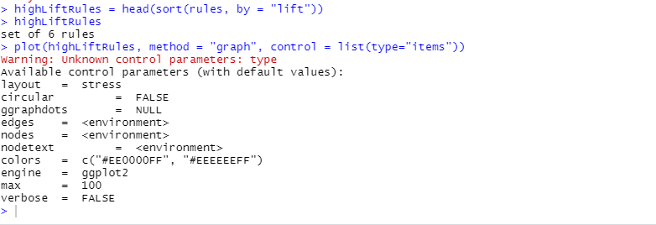

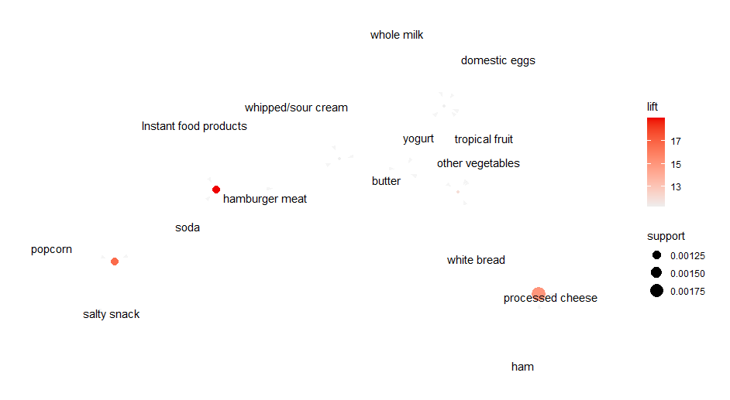

**CONCLUSION**

The Practical to Perform Association mining on the Groceries dataset was successfully executed.

**PRACTICAL NO 5**

**AIM** - Create a decision tree for the Bank-Sample dataset. Predict the outcome for following job="retired", marital="married", education="secondary", default="no", housing="yes", loan="no", contact = "cellular", duration = 598,  poutcome="unknown"

**STEPS:**

**1-**library("rpart")

library("rpart.plot")

# Read the data

setwd("C:\Users\PRIYANKA\Desktop\Sem 2\BDA Practicals")

banktrain <- read.table("bank-sample.csv",header=TRUE,sep=",")

View(banktrain)

## drop a few columns to simplify the tree

drops<-c("age", "balance", "day", "campaign", "pdays", "previous", "month")

banktrain <- banktrain [,!(names(banktrain) %in% drops)]

View(banktrain)

summary(banktrain)

# Make a simple decision tree by only keeping the categorical variables

fit <- rpart(subscribed ~ job + marital + education + default + housing + loan + contact + poutcome,

method="class",

data=banktrain,

control=rpart.control(minsplit=1),

parms=list(split='information'))

summary(fit)

# Plot the tree

rpart.plot(fit, type=4, extra=2, clip.right.labs=FALSE, varlen=0, faclen=3)

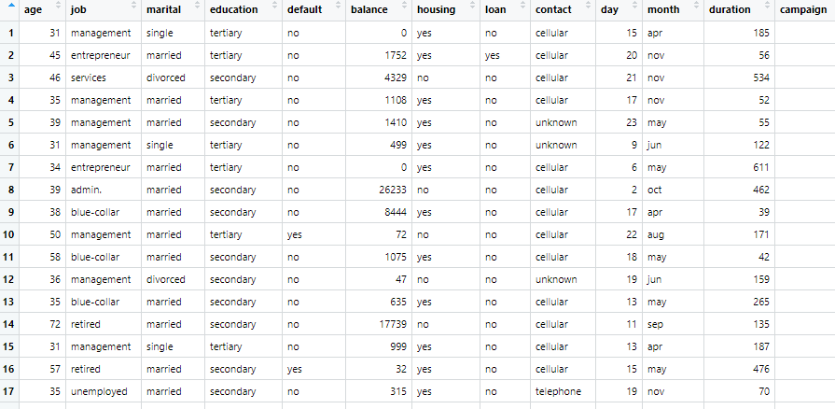

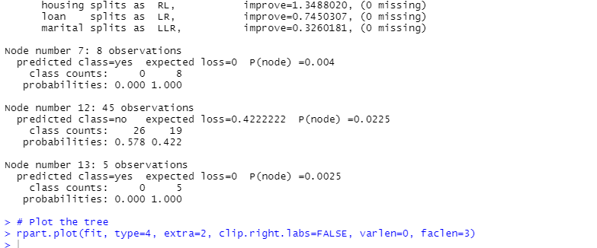

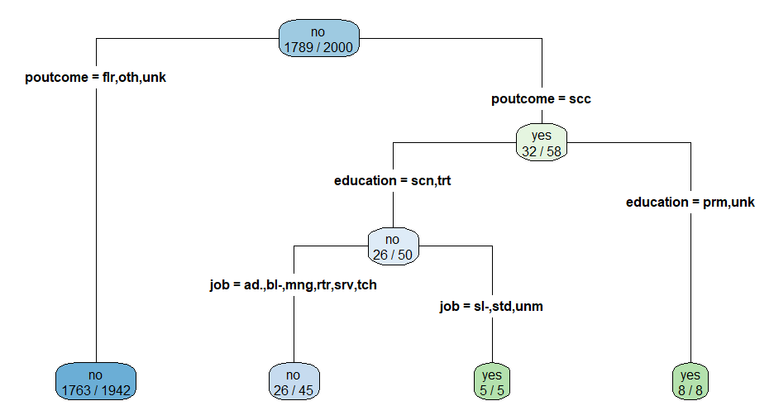

**2-** # include a numeric variable "duration" into the model

fit <- rpart(subscribed ~ job + marital + education + default + housing + loan + contact + duration + poutcome,

method="class",

data=banktrain,

control=rpart.control(minsplit=1),

parms=list(split='information'))

summary(fit)

# Plot the tree

rpart.plot(fit, type=4, extra=2, clip.right.labs=FALSE, varlen=0, faclen=3)

# Predict

newdata <- data.frame(job="retired",

marital="married",

education="secondary",

default="no",

housing="yes",

loan="no",

contact = "cellular",

duration = 598,

poutcome="unknown")

newdata

predict(fit,newdata=newdata,type=c("class"))

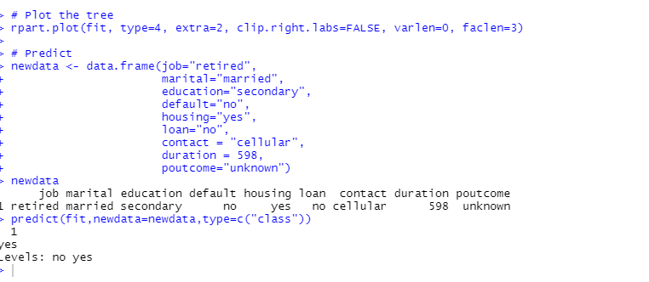

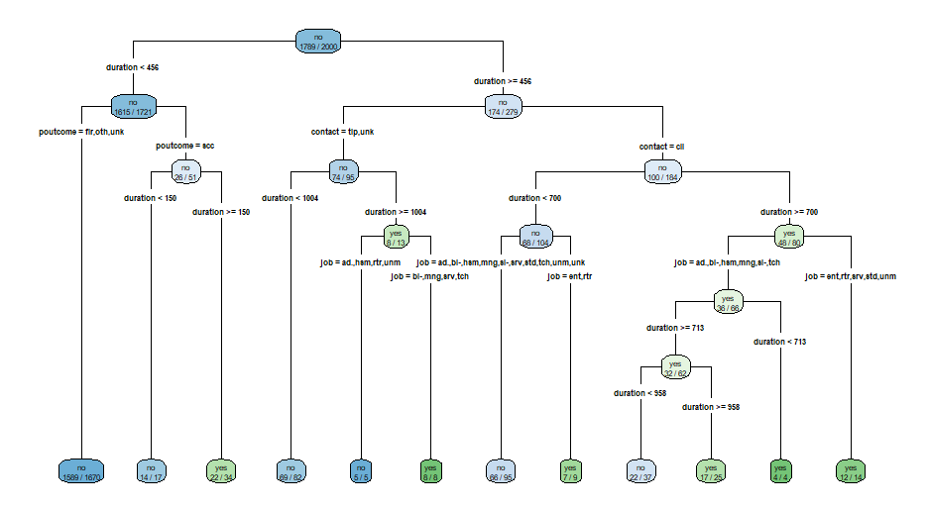

**CONCLUSION**

The Practical to Create a decision tree for the Bank-Sample dataset was successfully executed. The outcome for job="retired", marital="married", education="secondary", default="no", housing="yes", loan="no", contact = "cellular", duration = 598,  poutcome="unknown" was successfully predicted.

**PRACTICAL NO 6**

**AIM** - Create a decision tree for the DTdata dataset. Predict the outcome for following Outlook="rainy", Temperature="mild", Humidity="high", Wind=FALSE

**STEPS:**

**1-** #Decision Trees in R

library("rpart") # load libraries

library("rpart.plot")

# Read the data

play_decision <- read.csv("C:/Users/PRIYANKA/Desktop/Sem 2/BDA Practicals/DTdata.csv", header=TRUE, sep=",")

play_decision

summary(play_decision)

# build the decision tree

fit <- rpart(Play ~ Outlook + Temperature + Humidity + Wind,

method="class",

data=play_decision,

control=rpart.control(minsplit=1),

parms=list(split='information'))

summary(fit)

?rpart.plot

rpart.plot(fit, type=4, extra=1)

rpart.plot(fit, type=4, extra=2, clip.right.labs=FALSE,

varlen=0, faclen=0)

newdata <- data.frame(Outlook="rainy", Temperature="mild",

Humidity="high", Wind=FALSE)

newdata

predict(fit,newdata=newdata,type="prob")

predict(fit,newdata=newdata,type="class")

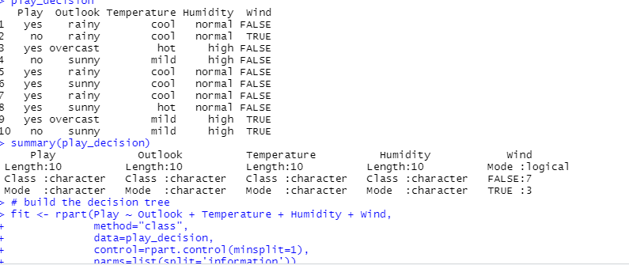

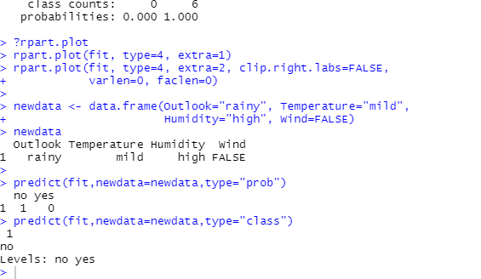

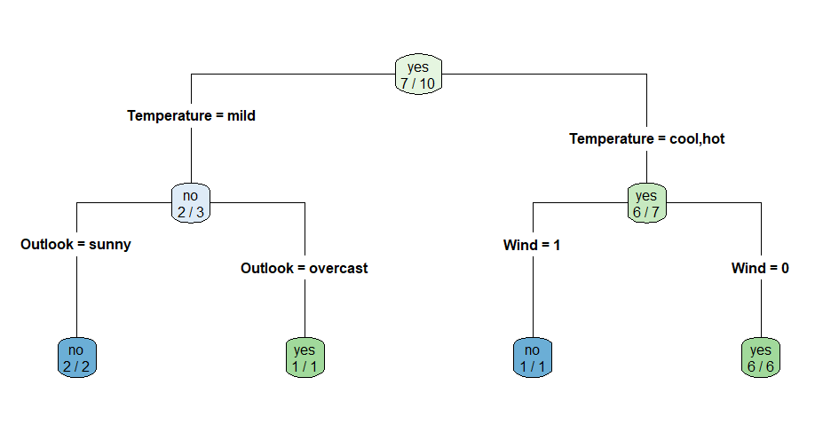

**CONCLUSION**

The Practical to Create a decision tree for the DTdata dataset was successfully executed. The outcome for Outlook="rainy", Temperature="mild", Humidity="high", Wind=FALSE was successfully Predicted.

**PRACTICAL NO 7**

**AIM**: Perform Simple Linear Regression on the INCOME dataset. Predict the income of a person with Age = 35, Education = 17 with confidence level of 95%

**STEPS:**

**1-**# Simple Linear Regression

###############################################################

income_input = as.data.frame( read.csv("C:/Users/PRIYANKA/Desktop/Sem 2/BDA Practicals/income.csv") )

View(income_input)

income_input[1:10,]

summary(income_input)

library(lattice)

splom(~income_input[c(2:5)], groups=NULL, data=income_input,

axis.line.tck = 0,

axis.text.alpha = 0)

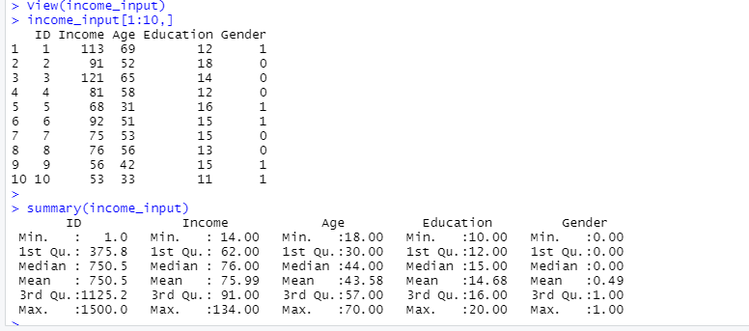

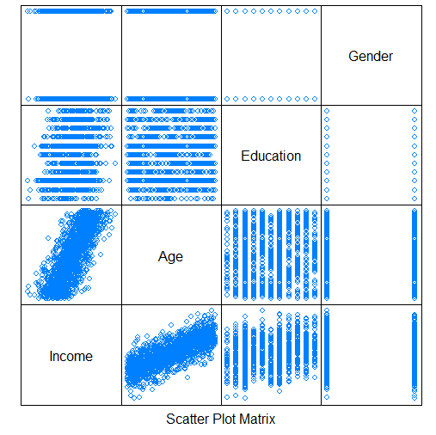

**2-**pairs(income_input[c(2:5)],)

results <- lm(Income~Age + Education + Gender, income_input)

summary(results)

results2 <- lm(Income ~ Age + Education, income_input)

summary(results2)

###############################################################

# compute confidence intevals for the model parameters

confint(results2, level = .95)

# compute a confidence interval on the expected income of a person

Age <- 41

Education <- 12

new_pt <- data.frame(Age, Education)

new_pt

conf_int_pt <- predict(results2, new_pt, level=.95, interval="confidence")

conf_int_pt

# compute a prediction interval on the income of the same person

pred_int_pt <- predict(results2, new_pt, level=.95, interval="prediction")

pred_int_pt

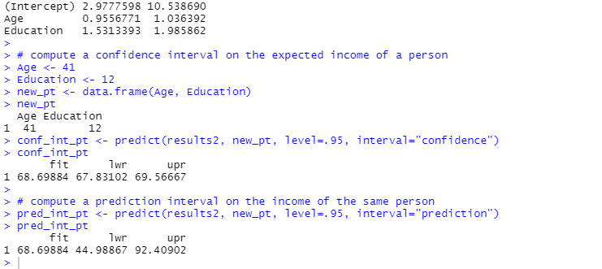

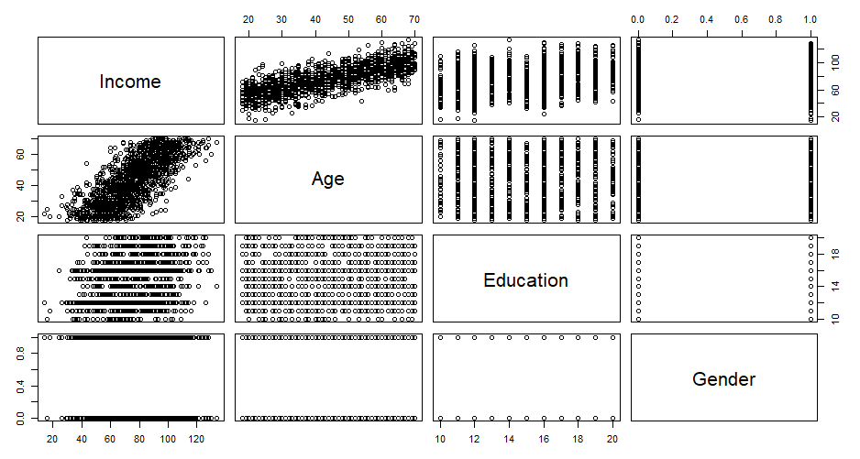

**CONCLUSION**

The Practical to Perform Simple Linear Regression on the INCOME dataset was successfully executed. The income of a person with Age = 35, Education = 17 with confidence level of 95%  was also Predicted successfully.

**PRACTICAL NO 8**

**AIM:** Perform Logistic Regression on the CHURN dataset. Plot the ROC curve and display the AUC

**STEPS:**

**1**- # Logistic Regression

###############################################################

churn_input = as.data.frame( read.csv("C:/Users/PRIYANKA/Desktop/Sem 2/BDA Practicals/churn.csv") )

View(churn_input)

head(churn_input)

summary(churn_input)

sum(churn_input$Churned)

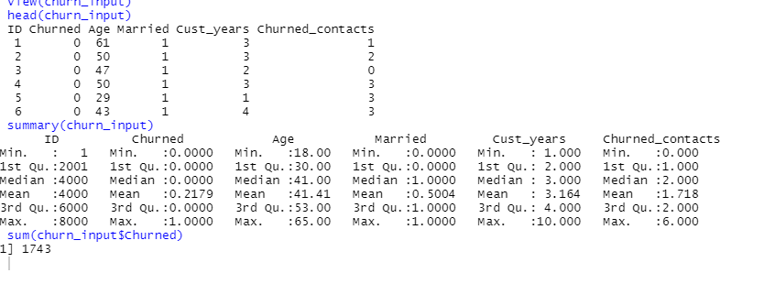

Churn_logistic1 <- glm (Churned~Age + Married + Cust_years + Churned_contacts,

data=churn_input, family=binomial(link="logit"))

summary(Churn_logistic1)

Churn_logistic2 <- glm (Churned~Age + Married + Churned_contacts,

data=churn_input, family=binomial(link="logit"))

summary(Churn_logistic2)

Churn_logistic3 <- glm (Churned~Age + Churned_contacts,

data=churn_input, family=binomial(link="logit"))

summary(Churn_logistic3)

summary(Churn_logistic2)

pchisq(.9 , 1, lower=FALSE)

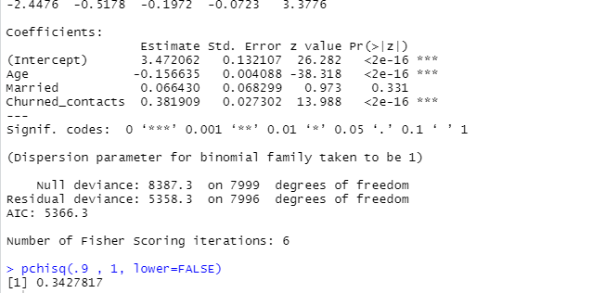

# Receiver Operating Characteristic (ROC) Curve

install.packages("ROCR") #install, if necessary

library(ROCR)

pred = predict(Churn_logistic3, type="response")

predObj = prediction(pred, churn_input$Churned )

predObj

rocObj = performance(predObj, measure="tpr", x.measure="fpr")

aucObj = performance(predObj, measure="auc")

summary(aucObj)

plot(rocObj, main = paste("Area under the curve:", round(aucObj@y.values[[1]] ,4)))

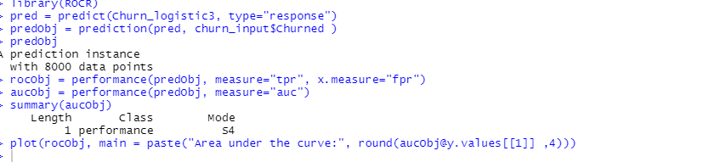

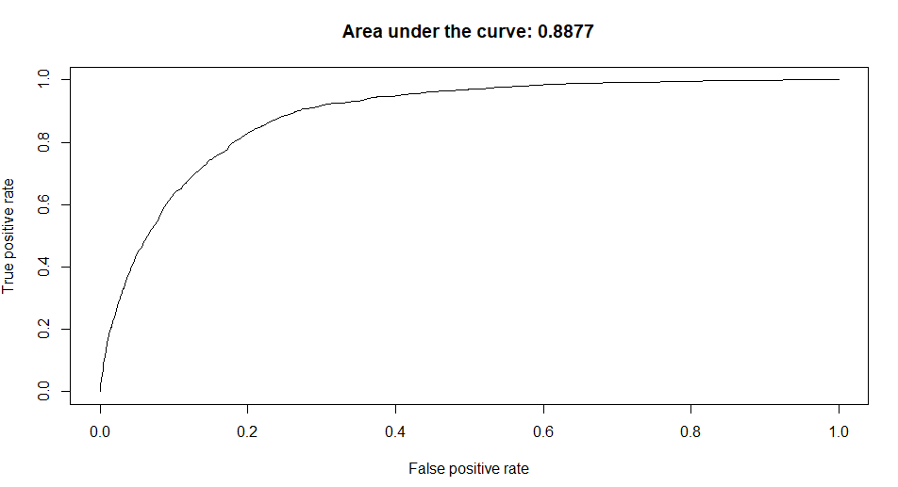

**CONCLUSION**

The Practical to Perform Logistic Regression on the CHURN dataset was successfully executed.

**PRACTICAL NO 9**

**AIM -** Install Hadoop in Stand-Alone Mode on Ubuntu

**STEPS**

**1** - Installing Java

To get started, we’ll update our package list:

**sudo apt update**

Next, we’ll install OpenJDK, the default Java Development Kit on Ubuntu 18.04:

**sudo apt install default-jdk**

Once the installation is complete, let’s check the version.

**java -version**

This output verifies that OpenJDK has been successfully installed.

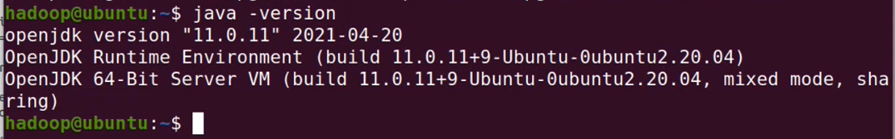

Create a new user- hadoop

**sudo adduser hadoop**

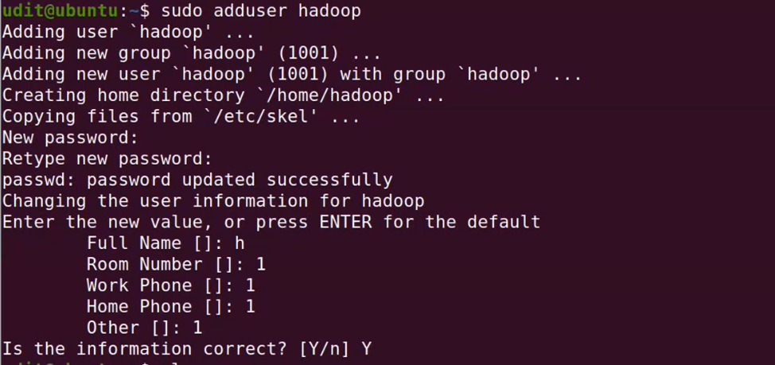

Give all priviliges to hadoop

**sudo nano /etc/sudoers**



Add the line

**user_name ALL=(ALL:ALL) ALL**

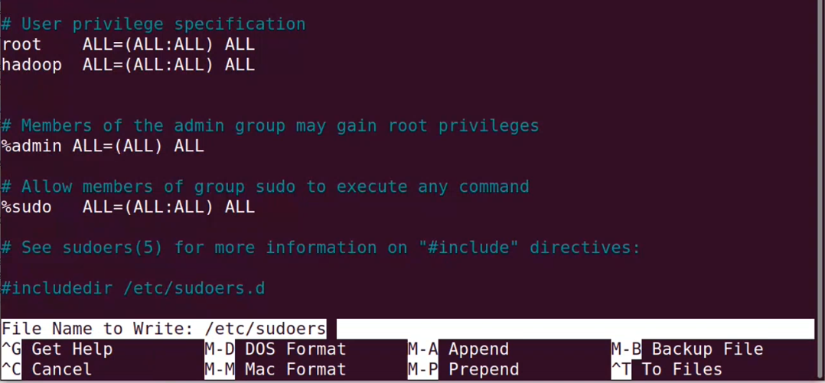

switch user to hadoop

**su - hadoop**

The prompt should look like this - **hadoop15@ubuntu:/**



**sudo apt update**

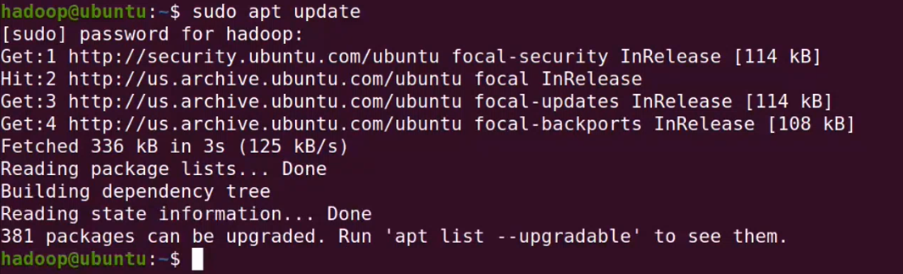

It is also required to set up key-based ssh

**ssh-keygen -t rsa -P '' -f ~/.ssh/id_rsa**

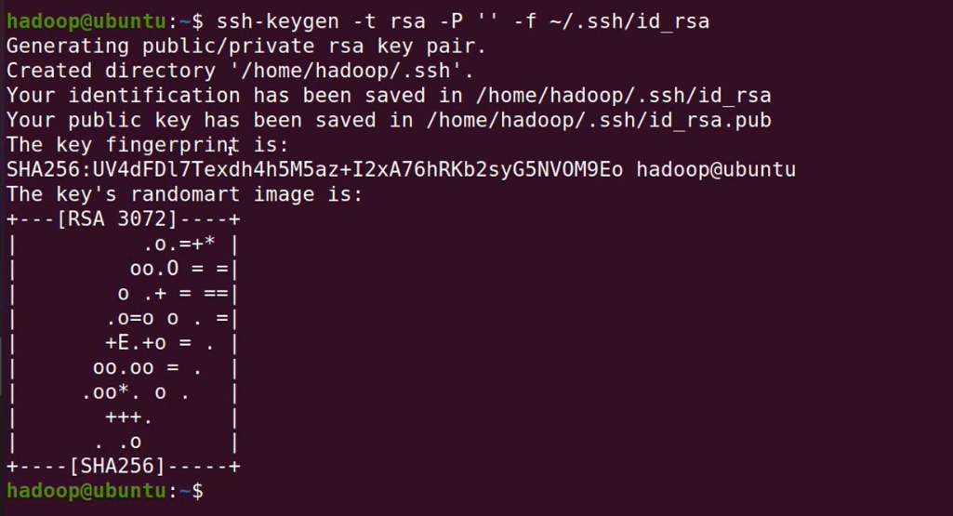

**cat ~/.ssh/id_rsa.pub >> ~/.ssh/authorized_keys**

**chmod 0600 ~/.ssh/authorized_keys**



verify key based login

**ssh localhost**

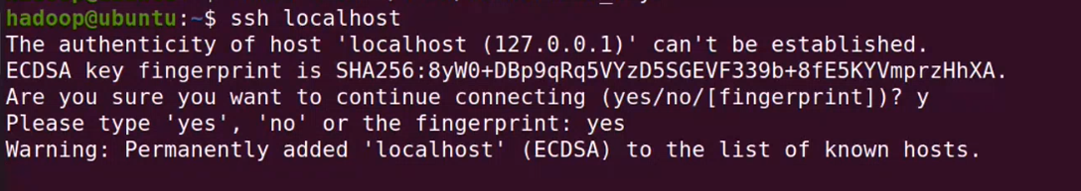

**2** - Installing Hadoop

Visit the Apache Hadoop Releases page to find the most recent stable release.

https://hadoop.apache.org/release/3.2.2.html

we’ll install Hadoop 3.2.2.

**There are 2 options to download and install hadoop**

1. Download and install using one single command

**wget https://hadoop.apache.org/release/3.2.2.html/hadoop-3.2.2.tar.gz**

This will download the mentioned version and then install it on your system

2. If the above does not work then go to the webpage of Apache Hadoop, download it manually and then install it

visit website

https://hadoop.apache.org/release/3.2.2.html

Click button that says **"Download tar.gz"** (download the latest version)

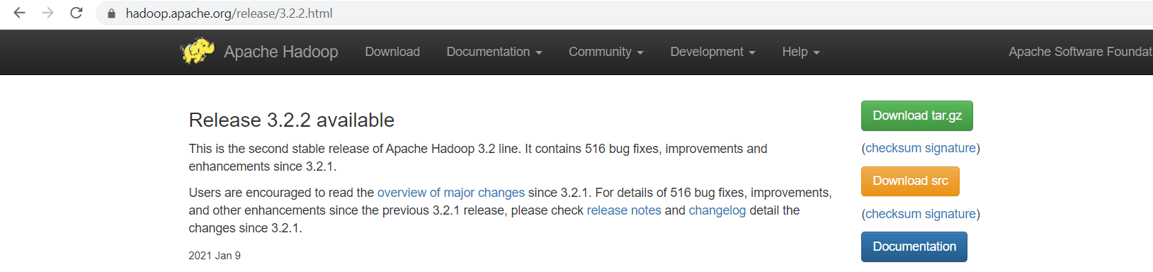

copy the existing setup to /home/hadoop/

**sudo mv /home/udit/Desktop/Prac/setups/hadoop-3.2.0.tar.gz /home/Hadoop**



Extract hadoop using the following command

we’ll use the tar command with the -x flag to extract, -z to uncompressed, -v for verbose output, and -f to specify that we’re extracting from a file.

**tar xzvf hadoop-3.2.0.tar.gz**



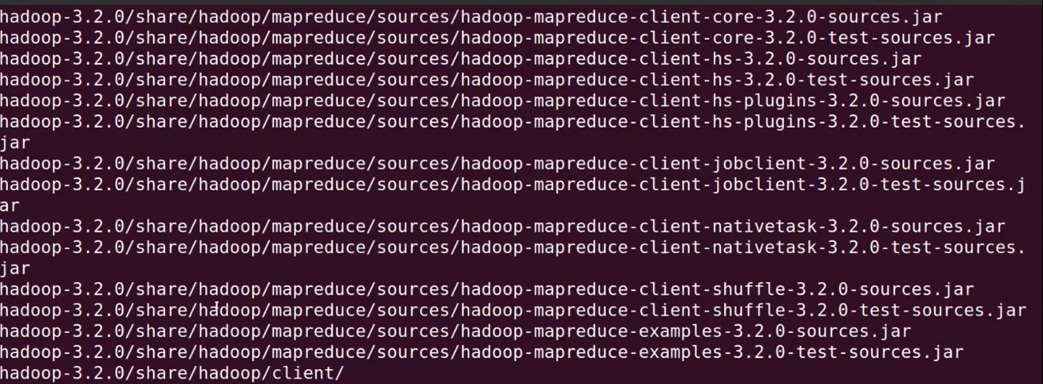

Set path for Java & Hadoop

**sudo nano .bashrc**



**export JAVA_HOME=/lib/jvm/java-11-openjdk-amd64**

**export PATH=$PATH:$JAVA_HOME/bin**

**export HADOOP_HOME=/home/hadoop/hadoop-3.2.0**

**export HADOOP_COMMON_HOME=/home/hadoop/hadoop-3.2.0**

**export HADOOP_MAPRED_HOME=/home/hadoop/hadoop-3.2.0**

**export PATH=$PATH:$HADOOP_COMMON_HOME/bin**

**export PATH=$PATH:$HADOOP_COMMON_HOME/sbin**

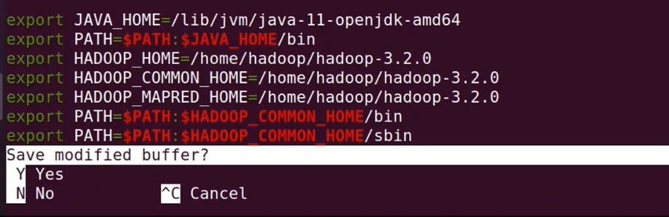

After doing all changes and saving the file run the following command to make changes through the .bashrc file.

**source ~/.bashrc**



Checking java and Hadoop

**Command: java -version**

**Command: Hadoop version**

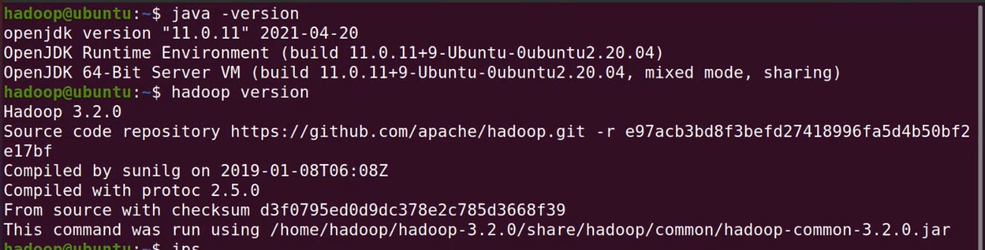

**3 -Configuring Hadoop’s Java Home**

Hadoop requires that you set the path to Java, either as an environment variable or in the Hadoop configuration file.

To Configure Hadoop’s Java Home, begin by opening Hadoop-env.sh

**Sudo nano $HADOOP_HOME/etc/Hadoop/Hadoop-env.sh**



Add the following line at the end of .sh file

**export JAVA_HOME=/usr/lib/JVM/java-11-OpenJDK-amd64/**

to save the changes in the file, press Ctrl and x together.

then press **Y** then press Enter key



**4-** Running Hadoop

Now we should be able to run Hadoop:

**$HADOOP_HOME/bin/Hadoop**

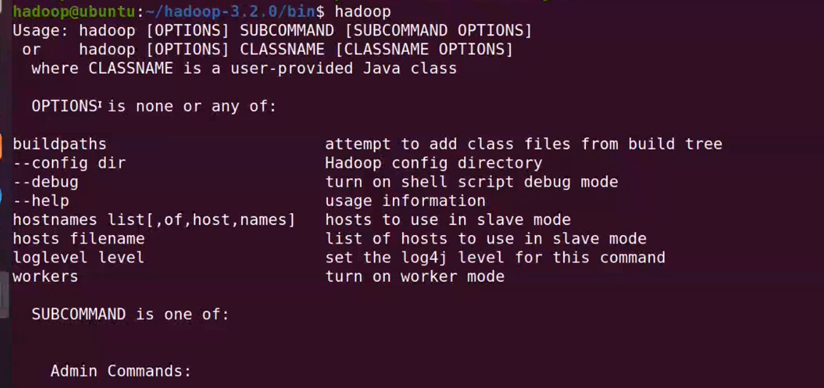

The help means we’ve successfully configured Hadoop to run in stand-alone mode.

Next we will create a directory called input in our home directory and copy Hadoop’s configuration files into it to use those files as our data**.**

**mkdir ~/input**

**cp $HADOOP_HOME/etc/hadoop/*.xml ~/input**



Next, we can use the following command to run the MapReduce hadoop-mapreduce-examples program, a Java archive with several options.

We’ll invoke its grep program, one of the many examples included in hadoop-mapreduce-examples, followed by the input directory, input and the output directory grep_example.

The MapReduce grep program will count the matches of a literal word or regular expression.

Finally, we’ll supply the regular expression allowed[.]* to find occurrences of the word allowed within or at the end of a declarative sentence.

The expression is case-sensitive, so we wouldn’t find the word if it were capitalized at the beginning of a sentence:

**$HADOOP_HOME/bin/hadoop jar $HADOOP_HOME/share/hadoop/mapreduce/hadoop-mapreduce-examples-3.2.0.jar grep ~/input ~/grep_example 'allowed[.]*'**

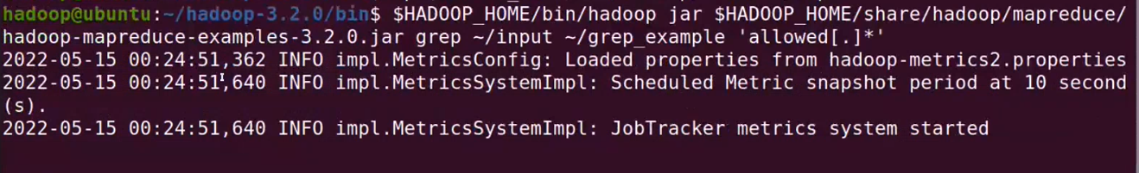

When the task completes, it provides a summary of what has been processed and errors it has encountered, but this doesn’t contain the actual results.

Results are stored in the output directory and can be checked by running cat on the output directory:

**cat ~/grep_example/\***



**CONCLUSION**

The Practical to Install Hadoop in Stand-Alone Mode on Ubuntu was successfully executed.

**PRACTICAL NO 10**

**AIM-** Install Hadoop in Pseudo Distributed Mode on Ubuntu

**STEPS**

**1-** To get started, we’ll update our package list:

**sudo apt update**

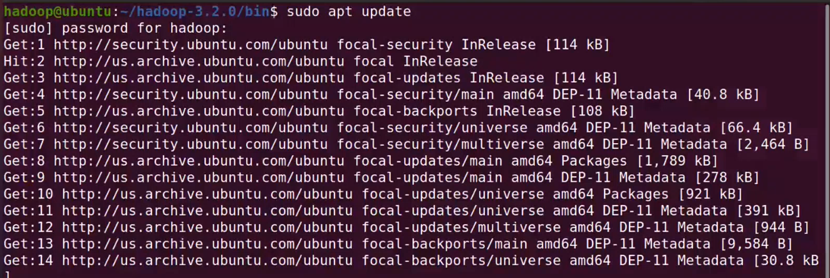

Next, we’ll install OpenJDK, the default Java Development Kit on Ubuntu 18.04:

**sudo apt install default-JDK**

Once the installation is complete, let’s check the version.

**java -version**

This output verifies that OpenJDK has been successfully installed.



Create a new user- Hadoop

**sudo adduser Hadoop**



Give all priviliges to hadoop

**sudo nano /etc/sudoers**



Add the line

**user_name ALL=(ALL:ALL) ALL**



switch user to hadoop15

**su - hadoop**

The prompt shoud look like this - hadoop@ubuntu:/



It is also required to set up key-based ssh

**ssh-keygen -t rsa -P '' -f ~/.ssh/id_rsa**



**cat ~/.ssh/id_rsa.pub >> ~/.ssh/authorized_keys**

**chmod 0600 ~/.ssh/authorized_keys**



verify key-based login

**ssh localhost**



**2-** Downloading & Installing Hadoop

Visit the Apache Hadoop Releases page to find the most recent stable release.

https://hadoop.apache.org/release/3.2.0.html

we’ll install Hadoop 3.2.0.

There are 2 options to download and install Hadoop

1. Download and install using one single command

**wget https://hadoop.apache.org/release/3.2.0.html/hadoop-3.2.0.tar.gz**

This will download the mentioned version and then install it on your system

2. If the above does not work then go to the webpage of Apache Hadoop, download it manually and then install it

visit website

https://hadoop.apache.org/release/3.2.0.html

Click button that says "Download tar.gz" (download the latest version)



copy the existing setup to /home/hadoop/

**sudo mv /home/udit/Desktop/Prac/setups/hadoop-3.2.0.tar.gz /home/Hadoop**



install hadoop using the following command

we’ll use the tar command with the -x flag to extract, -z to uncompress, -v for verbose output, and -f to specify that we’re extracting from a file.

**tar xzvf hadoop-3.2.0.tar.gz**



Finally, we’ll move the extracted files into /usr/local, the appropriate place for locally installed software.

**sudo mv hadoop-3.2.0 /home/Hadoop**



**verify by navigating to /home/Hadoop**

Update 6 important files

1. **.bashrc**

**==============================================================**

Set path for Java & Hadoop

**sudo nano .bashrc**



**export JAVA_HOME=/usr/lib/jvm/java-11-openjdk-amd64**

**export PATH=$PATH:$JAVA_HOME/bin**

**export HADOOP_HOME = /home/hadoop15/hadoop-3.2.0**

**export HADOOP_INSTALL = $HADOOP_HOME**

**export HADOOP_COMMON_HOME = $HADOOP_HOME**

**export HADOOP_MAPRED_HOME = $HADOOP_HOME**

**export HADOOP_HDFS_HOME = $HADOOP_HOME**

**export HADOOP_YARN_HOME = $HADOOP_HOME**

**export HADOOP_COMMON_LIB_NATIVE_DIR = $HADOOP_HOME/lib/native**

**export PATH = $PATH:$HADOOP_HOME/sbin:$HADOOP_HOME/bin**

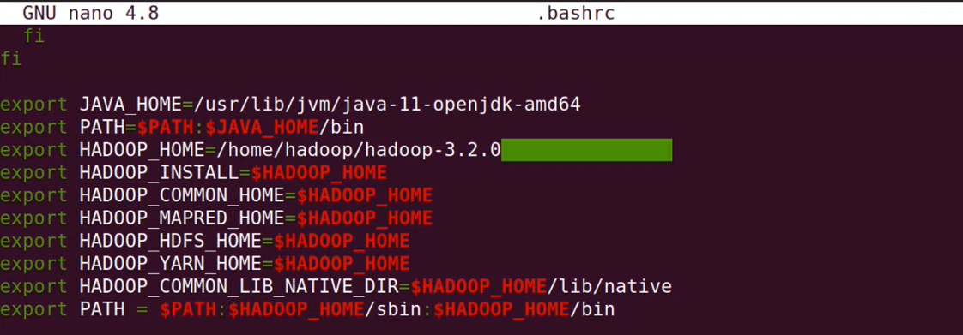

Execute by following line

**source ~/.bashrc**



Checking of java and hadoop

**Command: java -version**

**Command: hadoop version**



**==============================================================**

2 hadoop-env.sh - Configuring Hadoop’s Java Home

**==============================================================**

To Configure Hadoop15’s Java Home, begin by opening hadoop-env.sh

**sudo nano /home/hadoop/hadoop-3.2.0/etc/hadoop/hadoop-env.sh**



or use the variable $HADOOP_HOME

**sudo nano $HADOOP_HOME/etc/hadoop/hadoop-env.sh**

Add the following line at the end of .sh file

**export JAVA_HOME=/usr/lib/jvm/java-11-openjdk-amd64**



**==============================================================**

3 core-site.xml

**==============================================================**

**sudo nano $HADOOP_HOME/etc/hadoop/core-site.xml**



**<property>**

**<name>hadoop.tmp.dir</name>**

**<value>/home/hadoop/tmpdata</value>**

**<description>A base for other temporarary directories</description>**

**</property>**

**<property>**

**<name>fs.default.name</name>**

**<value>hdfs://localhost:9000</value>**

**<description>The name of the default file system.</description>**

**</property>**

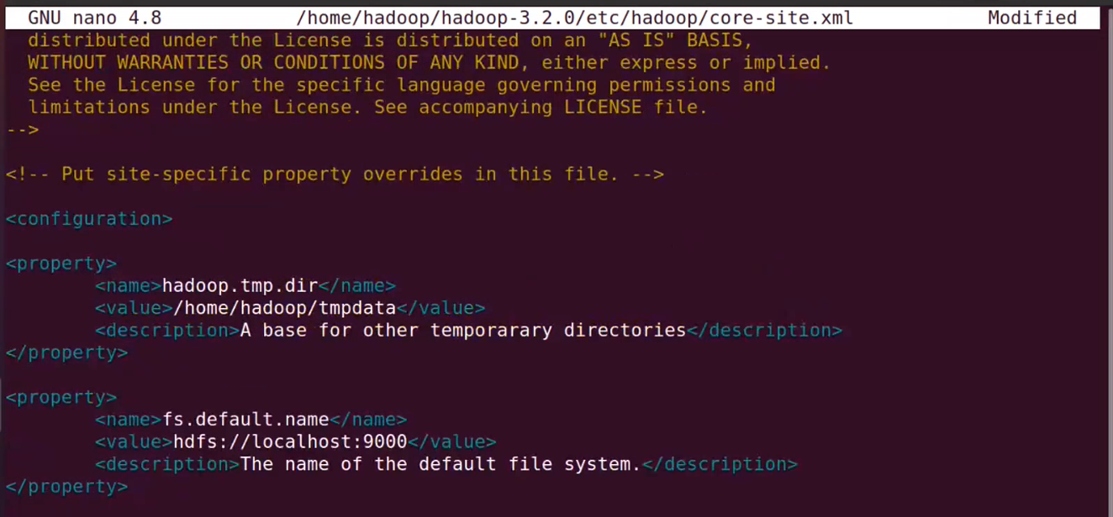

**==============================================================**

**4 hdfs-site.xml**

**==============================================================**

**sudo nano $HADOOP_HOME/etc/hadoop/hdfs-site.xml**



**<property>**

**<name>dfs.data.dir</name>**

**<value>/home/hadoop/dfsdata/namenode</value>**

**<description>Location of namenode</description>**

**</property>**

**<property>**

**<name>dfs.data.dir</name>**

**<value>/home/hadoop/dfsdata/datanode</value>**

**<description>Location of datanode</description>**

**</property>**

**<property>**

**<name>dfs.replication</name>**

**<value>1</value>**

**<description>Replication Factor</description>**

**</property>**

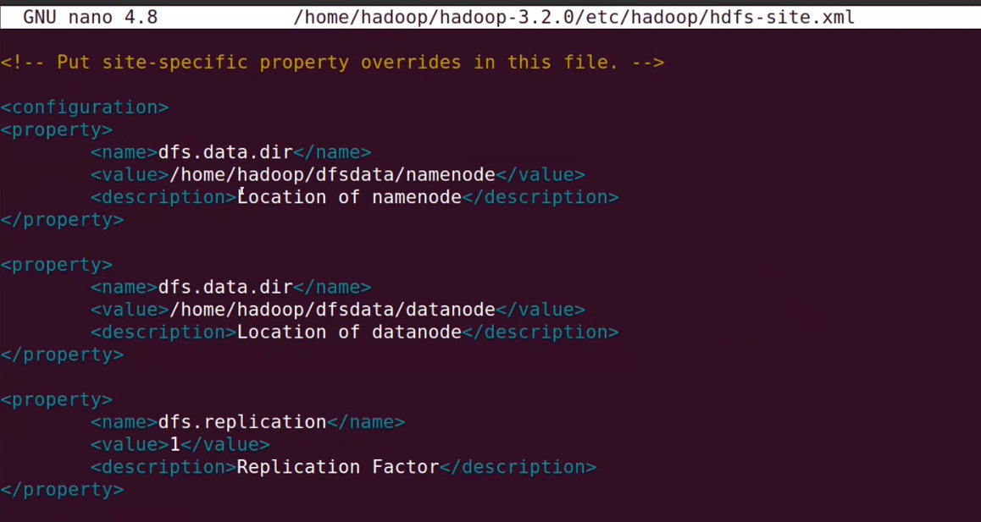

**==============================================================**

**5 mapred-site.xml**

**==============================================================**

**sudo nano $HADOOP_HOME/etc/hadoop/mapred-site.xml**



**<property>**

**<name>mapreduce.framework.name</name>**

**<value>yarn</value>**

**<description>Name of my mapreduce framework</description>**

**</property>**



**==============================================================**

**6 yarn-site.xml**

**==============================================================**

**sudo nano $HADOOP_HOME/etc/hadoop/yarn-site.xml**



**<property>**

**<name>yarn.nodemanager.aux-services</name>**

**<value>mapreduce_shuffle</value>**

**</property>**

**<property>**

**<name>yarn.nodemanager.aux-services.mapreduce.shuffle.class</name>**

**<value>org.apache.hadoop.mapred.ShuffleHandler</value>**

**</property>**

**<property>**

**<name>yarn.resourcemanager.hostname</name>**

**<value>127.0.0.1</value>**

**</property>**

**<property>**

**<name>yarn.acl.enable</name>**

**<value>0</value>**

**</property>**

**<property>**

**<name>yarn.nodemanager.env-whitelist</name>**

**<value>JAVA_HOME, HADOOP_COMMON_HOME, HADOOP_HDFS, HADOOP_YARN</value>**

**</property>**

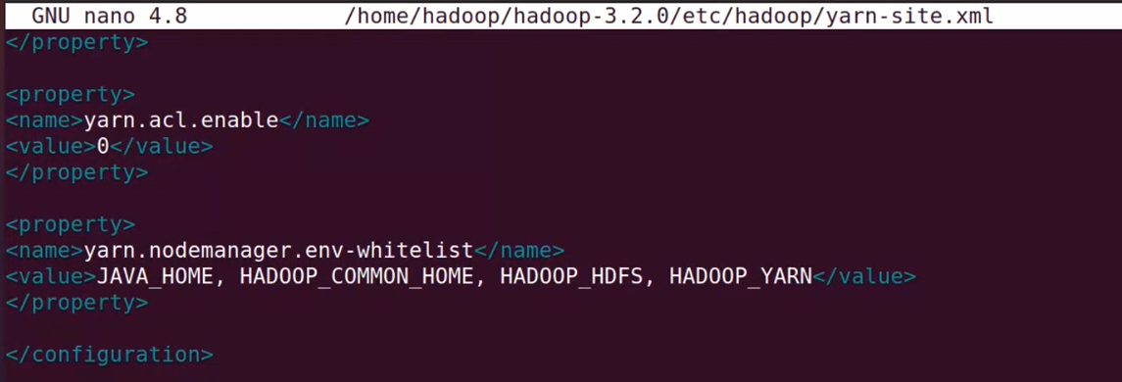

**==============================================================**

**Format Namenode**

**==============================================================**

move to the /bin folder

**cd /home/hadoop/hadoop-3.2.0/bin**



Now format the namenode using the following command

**hdfs namenode –format**





**==============================================================**

Start the namenode, datanode

**==============================================================**

move to the /sbin folder

**/home/hadoop/hadoop-3.2.0/sbin**

**start-dfs.sh**

**start-yarn.sh**

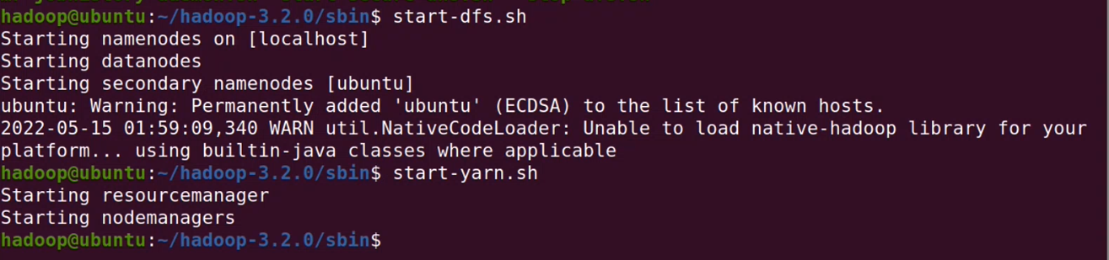

**==============================================================**

Start the task tracker and job tracker // Skip in case file not present

**==============================================================**

**start-mapred.sh**

**==============================================================**

To check if Hadoop started correctly

**==============================================================jps**

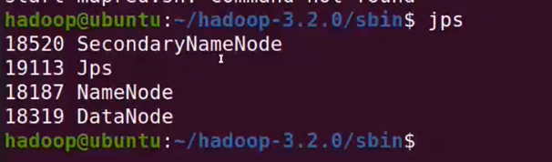

**==============================================================**

Copy file from local system to hdfs

**==============================================================**

**hdfs dfs -put source**

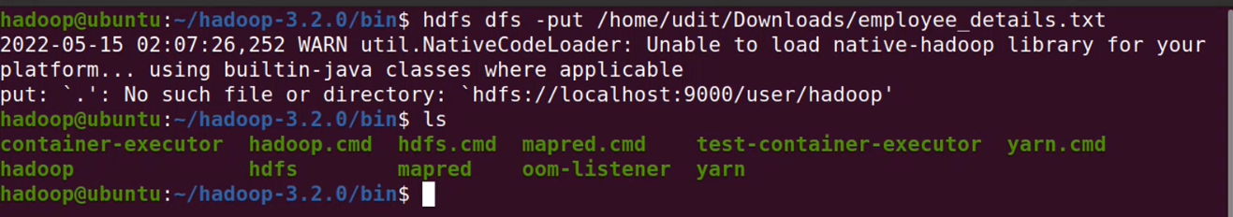

check using ls

**hdfs dfs -ls**

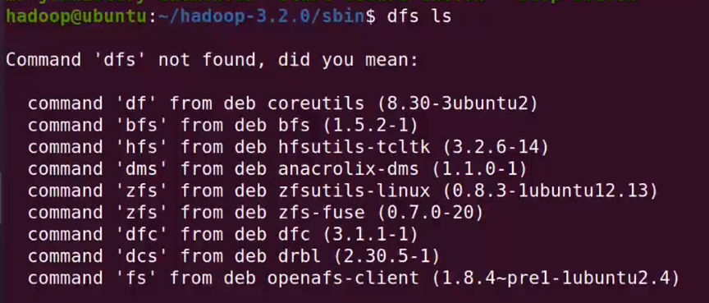

**==============================================================**

Check with browser

**==============================================================**

DFS overview **-** [**http://localhost:9000/**](http://localhost:9000/)

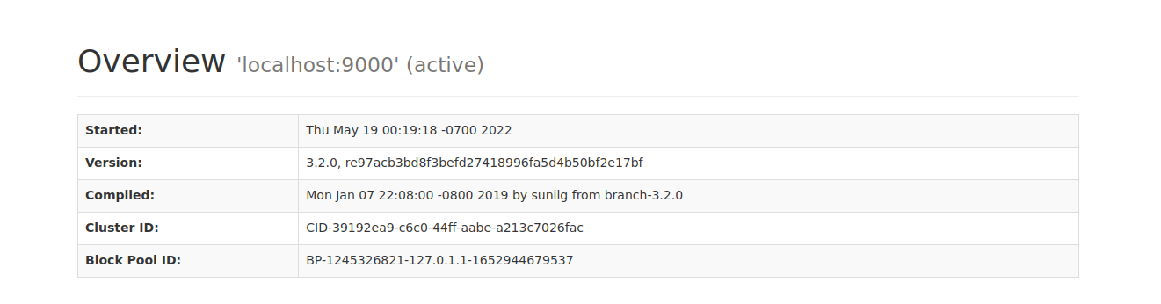

Data node  **-** [**http://localhost:9866/**](http://localhost:9866/)

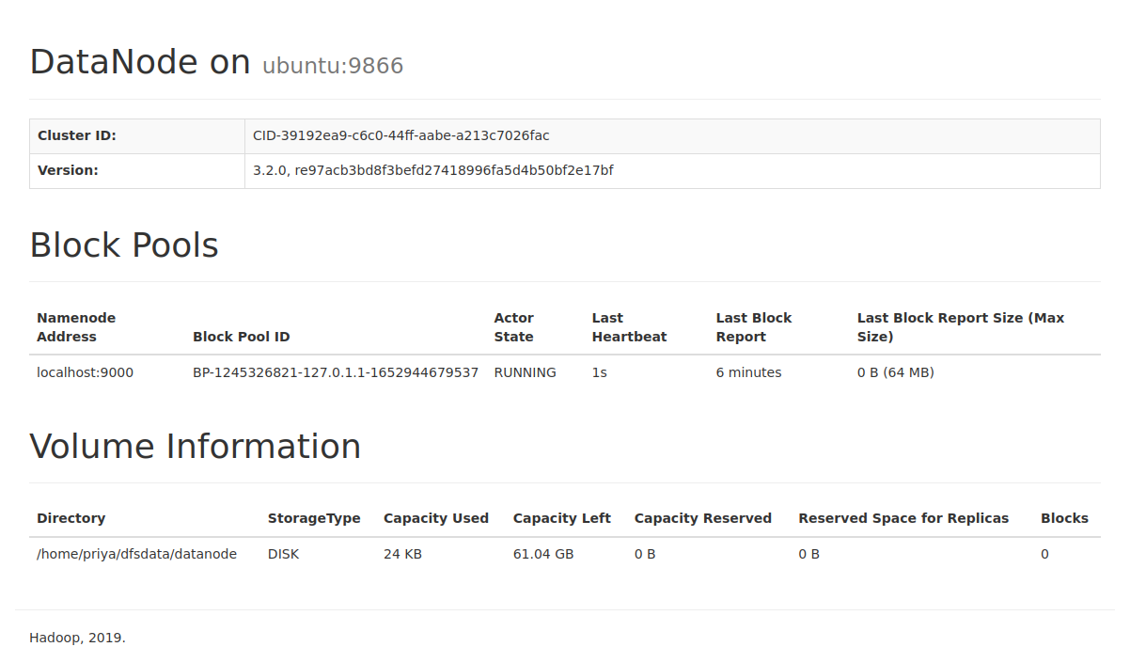

**CONCLUSION**

The Practical to Install Hadoop in Pseudo Distributed Mode on Ubuntu was successfully executed.